**What is Spring Security and why we need it?**

1. Spring Security is a framework which provides various security features like: authentication, authorization to create secure Java Enterprise Applications.
2. It is a sub-project of Spring framework which was started in 2003 by Ben Alex. Later on, in 2004, It was released under the Apache License as Spring Security 2.0.0.
3. It overcomes all the problems that come during creating non spring security applications and manage new server environment for the application.
4. This framework targets two major areas of application are authentication and authorization. Authentication is the process of knowing and identifying the user that wants to access.
5. **Authorization** is the process to allow authority to perform actions in the application.

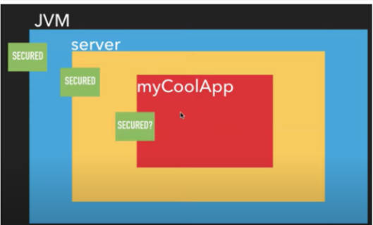

Applications are not secure but rest of things are secure like server and JVM, OS etc.

So, we need to make secure so need spring security.

**What are types of authentication?**

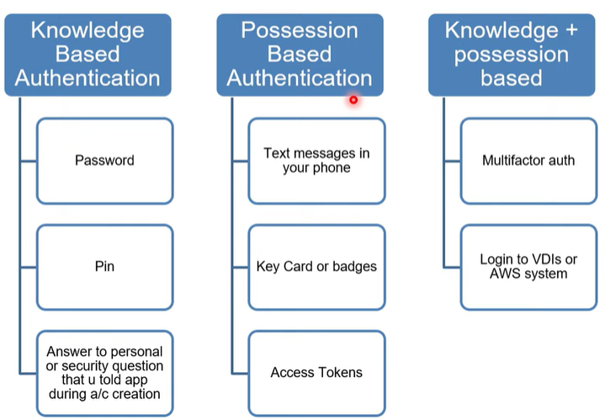

**What are the concept of spring security?**

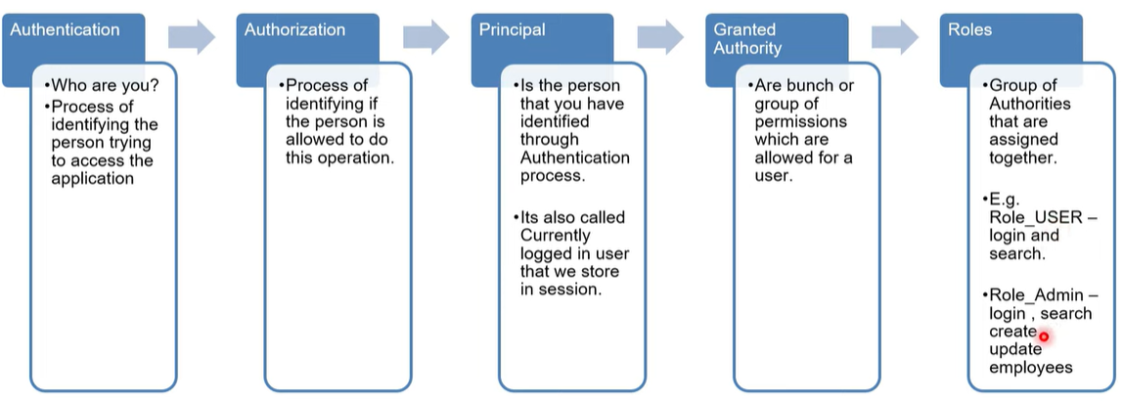

**What are all dependency required for spring security?**

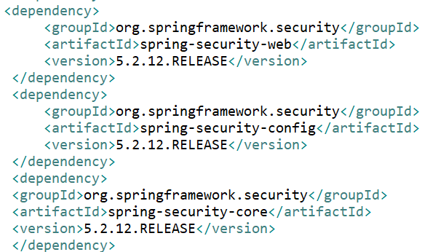

**What are advantages of spring security?**

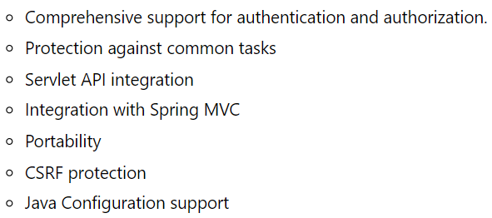

**What is Spring security features?**

* 1. Authorization: Spring Security provides the this feature to authorize the user before accessing resources. It allows developers to define access policies against the resources.
* 2. Remember me: Spring Security supports this feature with the help of HTTP Cookies. It remember to the user and avoid login again from the same machine until the user logout.
* 3. Digest Access Authentication: This feature allows us to make authentication process more secure than Basic Access Authentication. It asks to the browser to confirm the identity of the user before sending sensitive data over the network.
* 4. Basic Access Authentication: Spring Security supports Basic Access Authentication that is used to provide user name and password while making request over the network.
* New features added in spring 5:
* OAuth 2.0 login - This feature provides the facility to the user to login into the application by using their existing account at GitHub or Google. This feature is implemented by using the Authorization Code Grant that is specified in the OAuth 2.0 Authorization Framework.
* Reactive Support: From version Spring Security 5.0, it provides reactive programming and reactive web runtime support and even, we can integrate with Spring WebFlux.
* Modern password encoding: Spring Security 5.0 introduced new Password encoder **DelegatingPasswordEncoder** which is more modernize and solve all the problems of previous encoder **NoOpPasswordEncoder**.

**What is internal structure of spring security?**

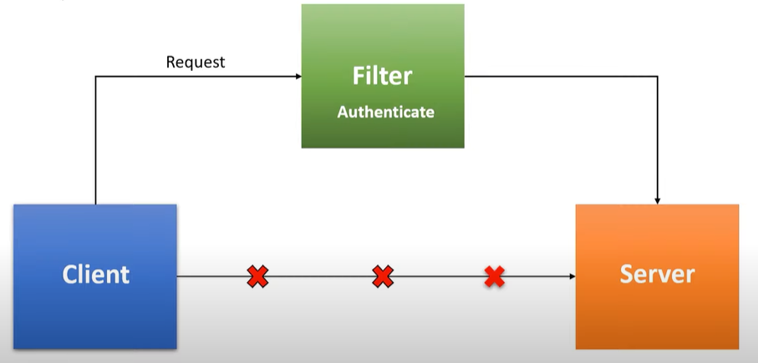

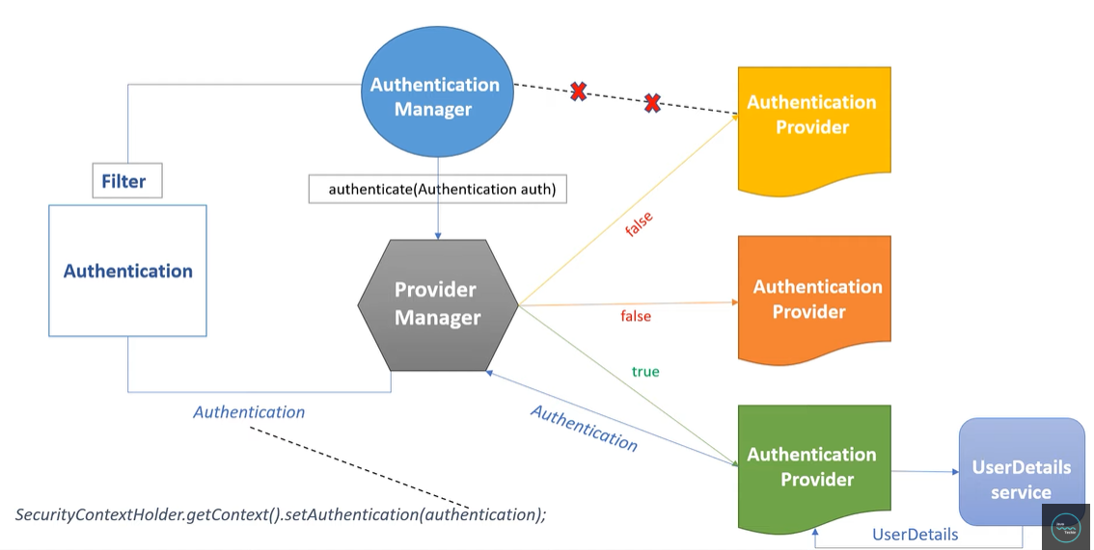

How to implement Spring Security using Spring Boot?

Dependency : <dependency>

<groupId>org.thymeleaf.extras</groupId>

<artifactId>thymeleaf-extras-springsecurity5</artifactId>

* </dependency>
* 
 